Power BI – ETL, Semantic Modeling, DAX &
Business Intelligence Dashboard Development
Jira Task Documentation

1. Objective
The task covers an end-to-end reporting workflow on multiple related datasets: preparing and cleaning the data, importing it, joining the tables into a model, creating calculated measures, and building an interactive dashboard.

2. Datasets Used
Three CSV datasets were used, linked by machine_id. These are the same machine datasets used in the earlier Snowflake task.
Dataset | Contents | Key fields shown
machines.csv | 15 machines | machine_id, machine_type, location, install_date, manufacturer
maintenance_logs.csv | 138 maintenance records (scorecard on the dashboard) | log_id, machine_id, maintenance_date, maintenance_type, cost_inr, downtime_hours, technician
sensor_readings.csv | 3,016 rows selected in the duplicate check (7 columns) | reading_id, machine_id, reading_date, temperature_c, vibration_mm_s, pressure_psi, rpm

machine_id is the primary key in machines and a foreign key in maintenance_logs and sensor_readings. That key is used for every join in Section 5.

3. Data Preparation and Cleaning
Cleaning was done in Google Sheets before the data was used in the report.

Duplicate check – sensor_readings
The Remove duplicates tool was run on sensor_readings with all 7 columns (Columns A to G) selected, over 3,016 rows. This checks for fully duplicated readings before reporting.
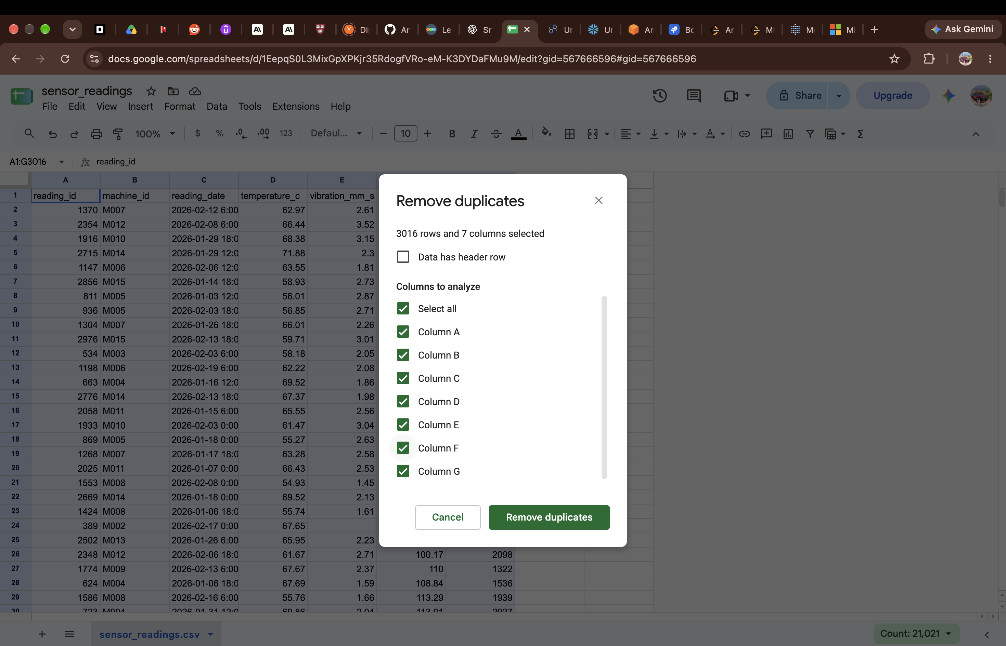
Figure 1 – Remove duplicates on sensor_readings, all 7 columns selected, 3,016 rows.

Trim whitespace – machines
Trim whitespace was run on the machines sheet. The result was: "No selected cells had whitespace trimmed." The sheet shows the 15 machines, M001 to M015, with machine_type, location, install_date and manufacturer.
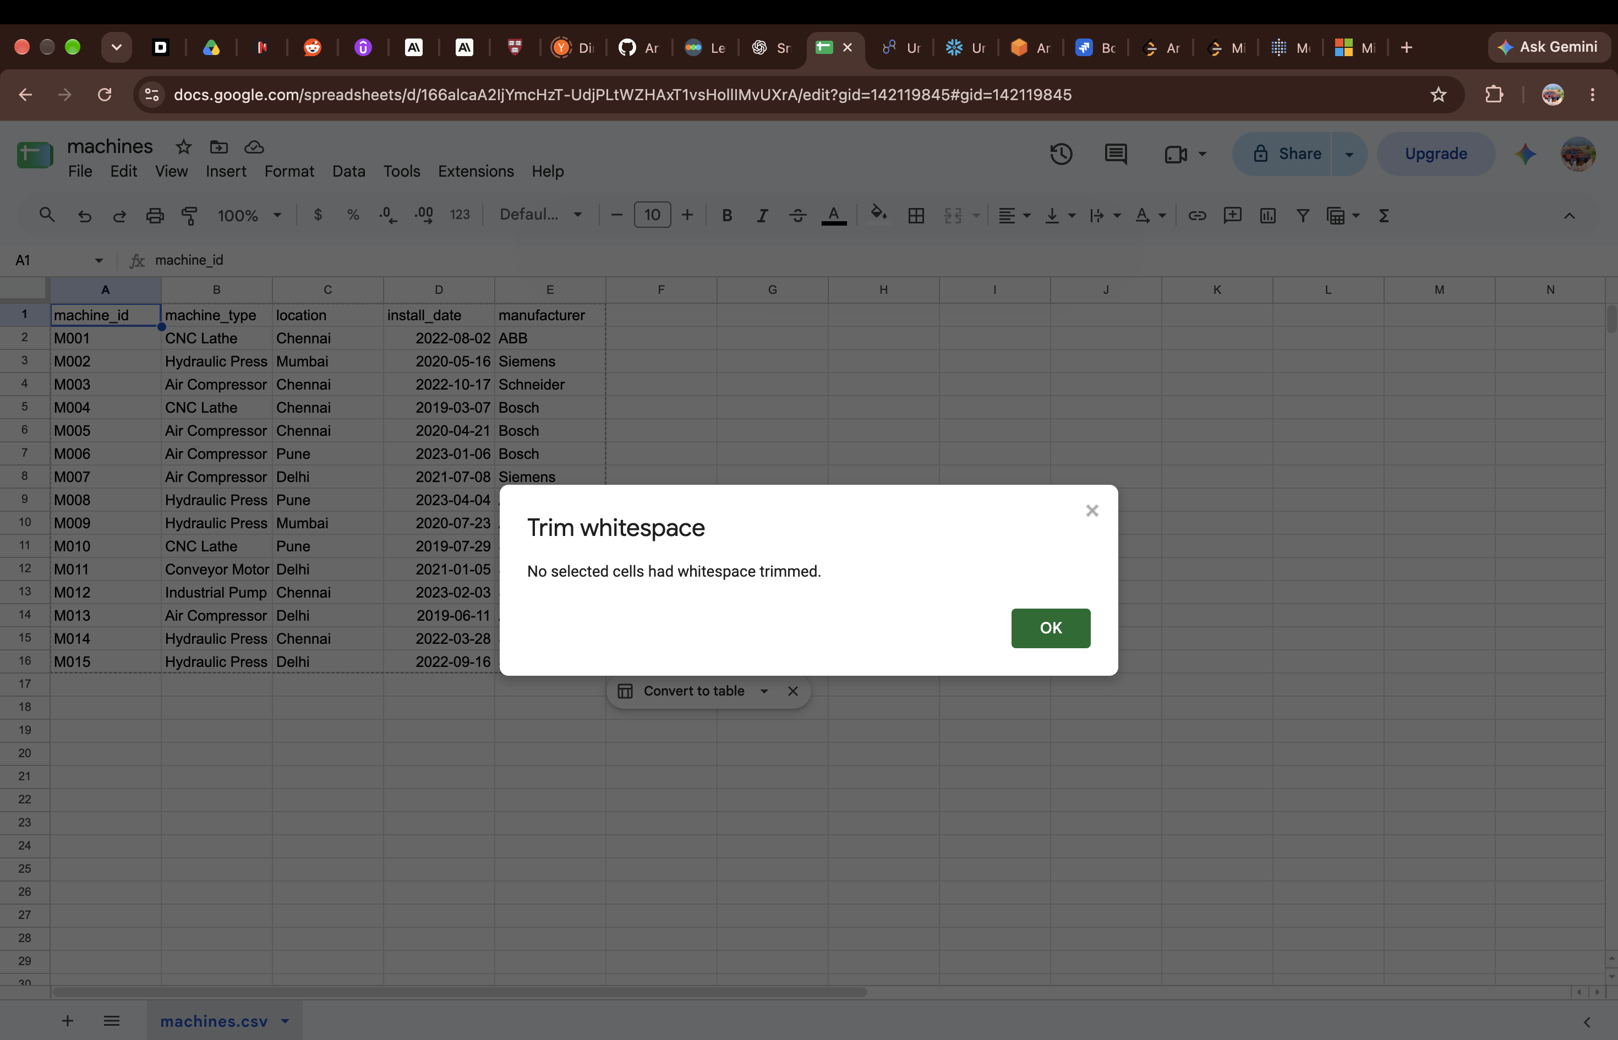
Figure 2 – Trim whitespace on machines – no cells needed trimming.

4. Data Import
Data was added to the report from Looker Studio using Add data. The connector list shows the available Google connectors, including Google Sheets and CSV File Upload.
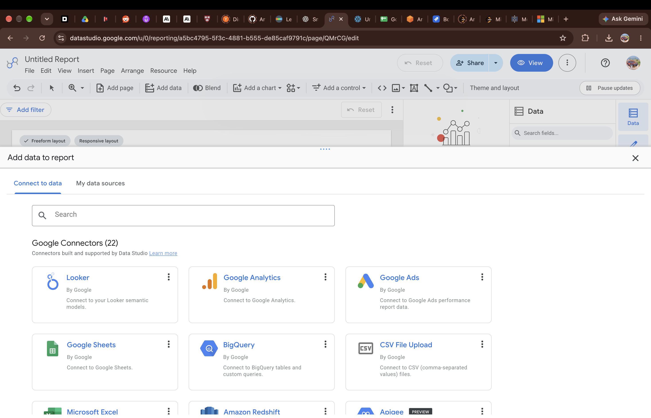
Figure 3 – Add data to report – connector options.
The Google Sheets connector was used. The maintenance_logs spreadsheet and its maintenance_logs.csv worksheet were selected, with "Use first row as headers" and "Include hidden and filtered cells" switched on. The same route was used for the other datasets – sensor_readings and machines appear in the spreadsheet list.
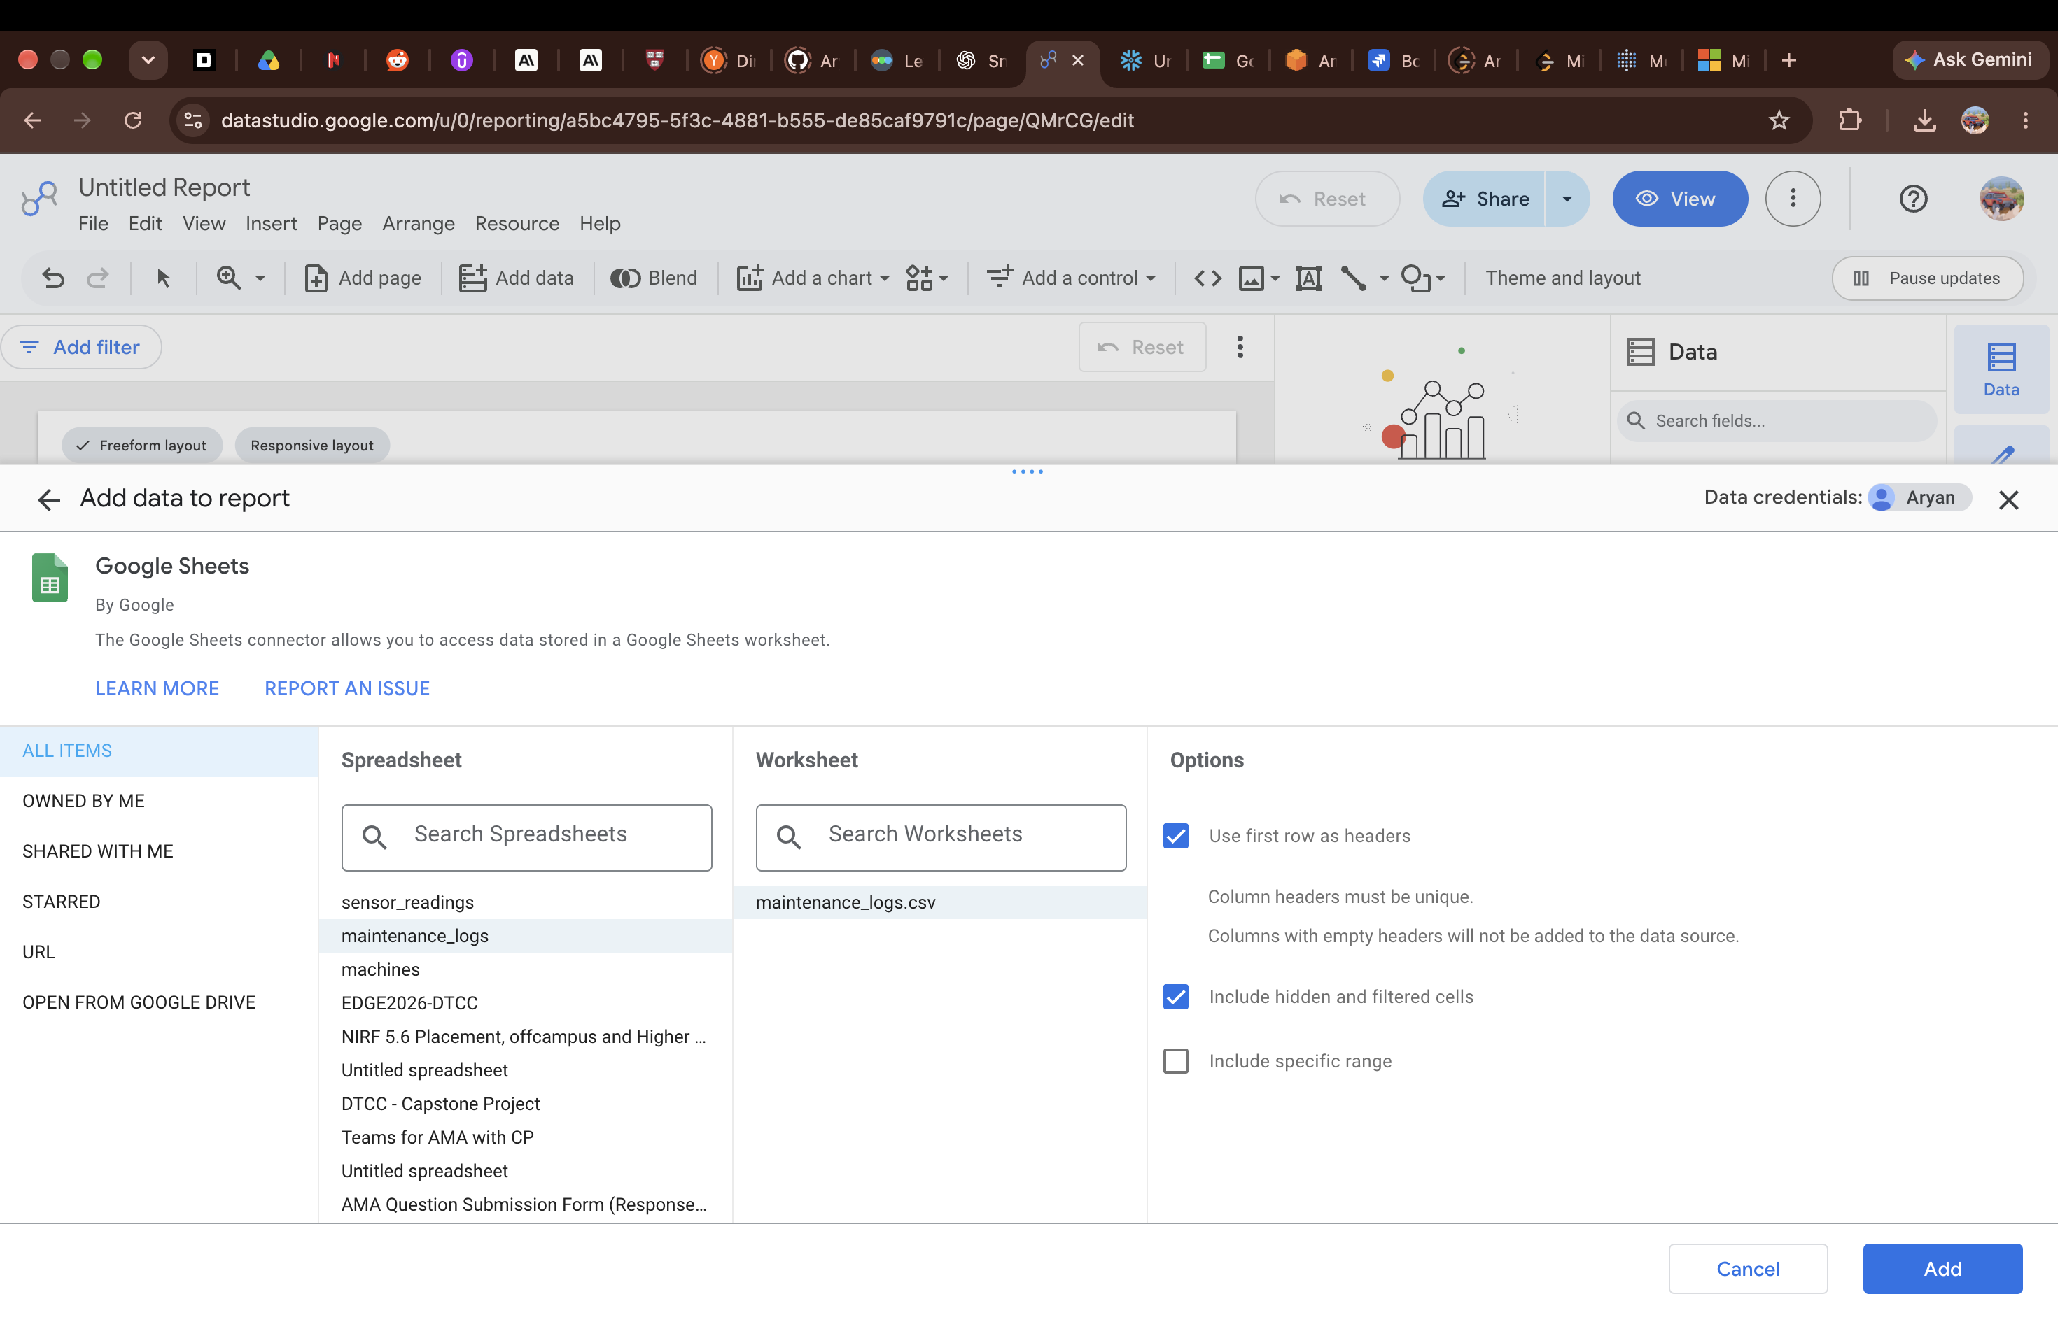
Figure 4 – Google Sheets connector – maintenance_logs selected, first row used as headers.

5. Data Modelling – Blends
Relationships were set up with Blend Data, joining tables on machine_id with one join condition each. "Hide repeated merge fields" was switched on, so the join key is not repeated in the blended output.

Blend 1 – machines with maintenance_logs
Dimensions taken from machines: location, manufacturer, machine_id, machine_type. Dimensions taken from maintenance_logs: downtime_hours, cost_inr, maintenance_type, machine_id. The blend was saved, as shown by the "Blend saved" message.
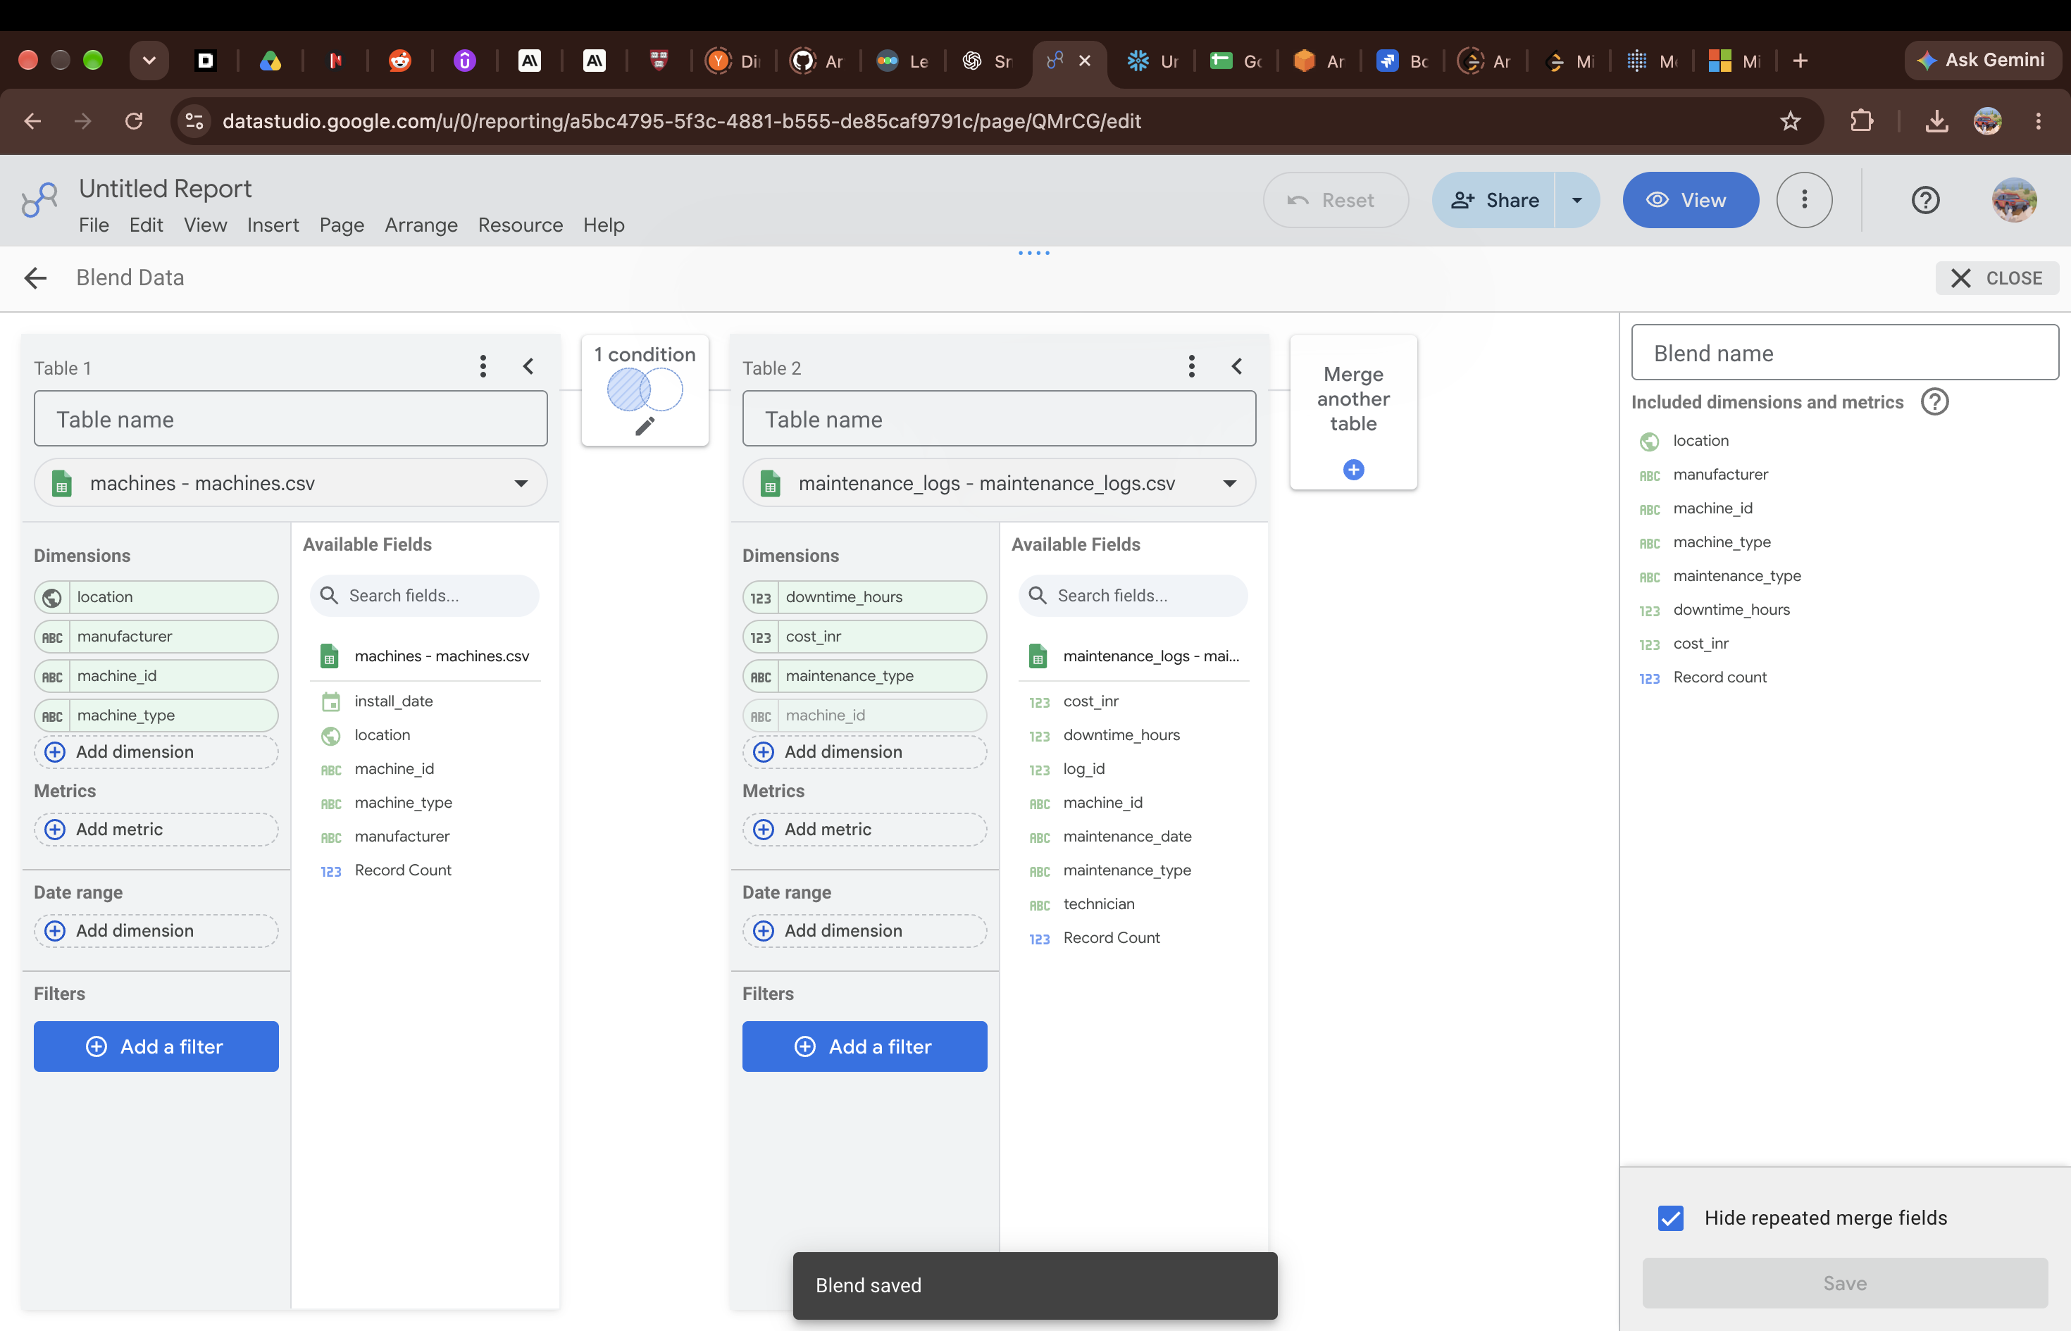
Figure 5 – Blend of machines and maintenance_logs – blend saved.

Blend 2 – machines with sensor_readings
The second blend joins machines with sensor_readings, also on machine_id.
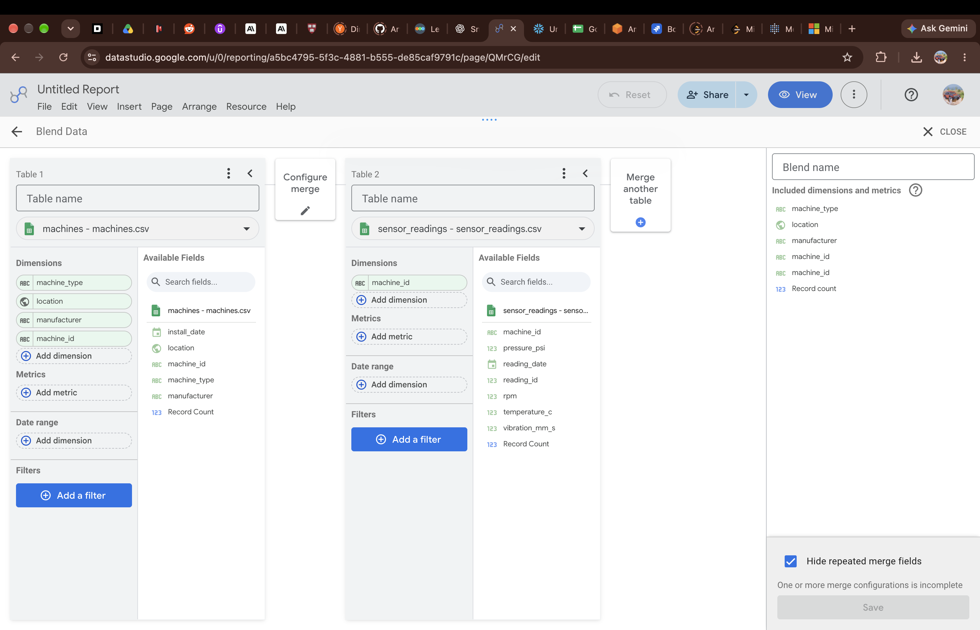
Figure 6 – Configuring the machines and sensor_readings blend on machine_id.
In the saved sensor blend, the fields carried into the report were machine_type, location, manufacturer and machine_id from machines, and rpm, pressure_psi, vibration_mm_s and temperature_c from sensor_readings, along with Record Count.
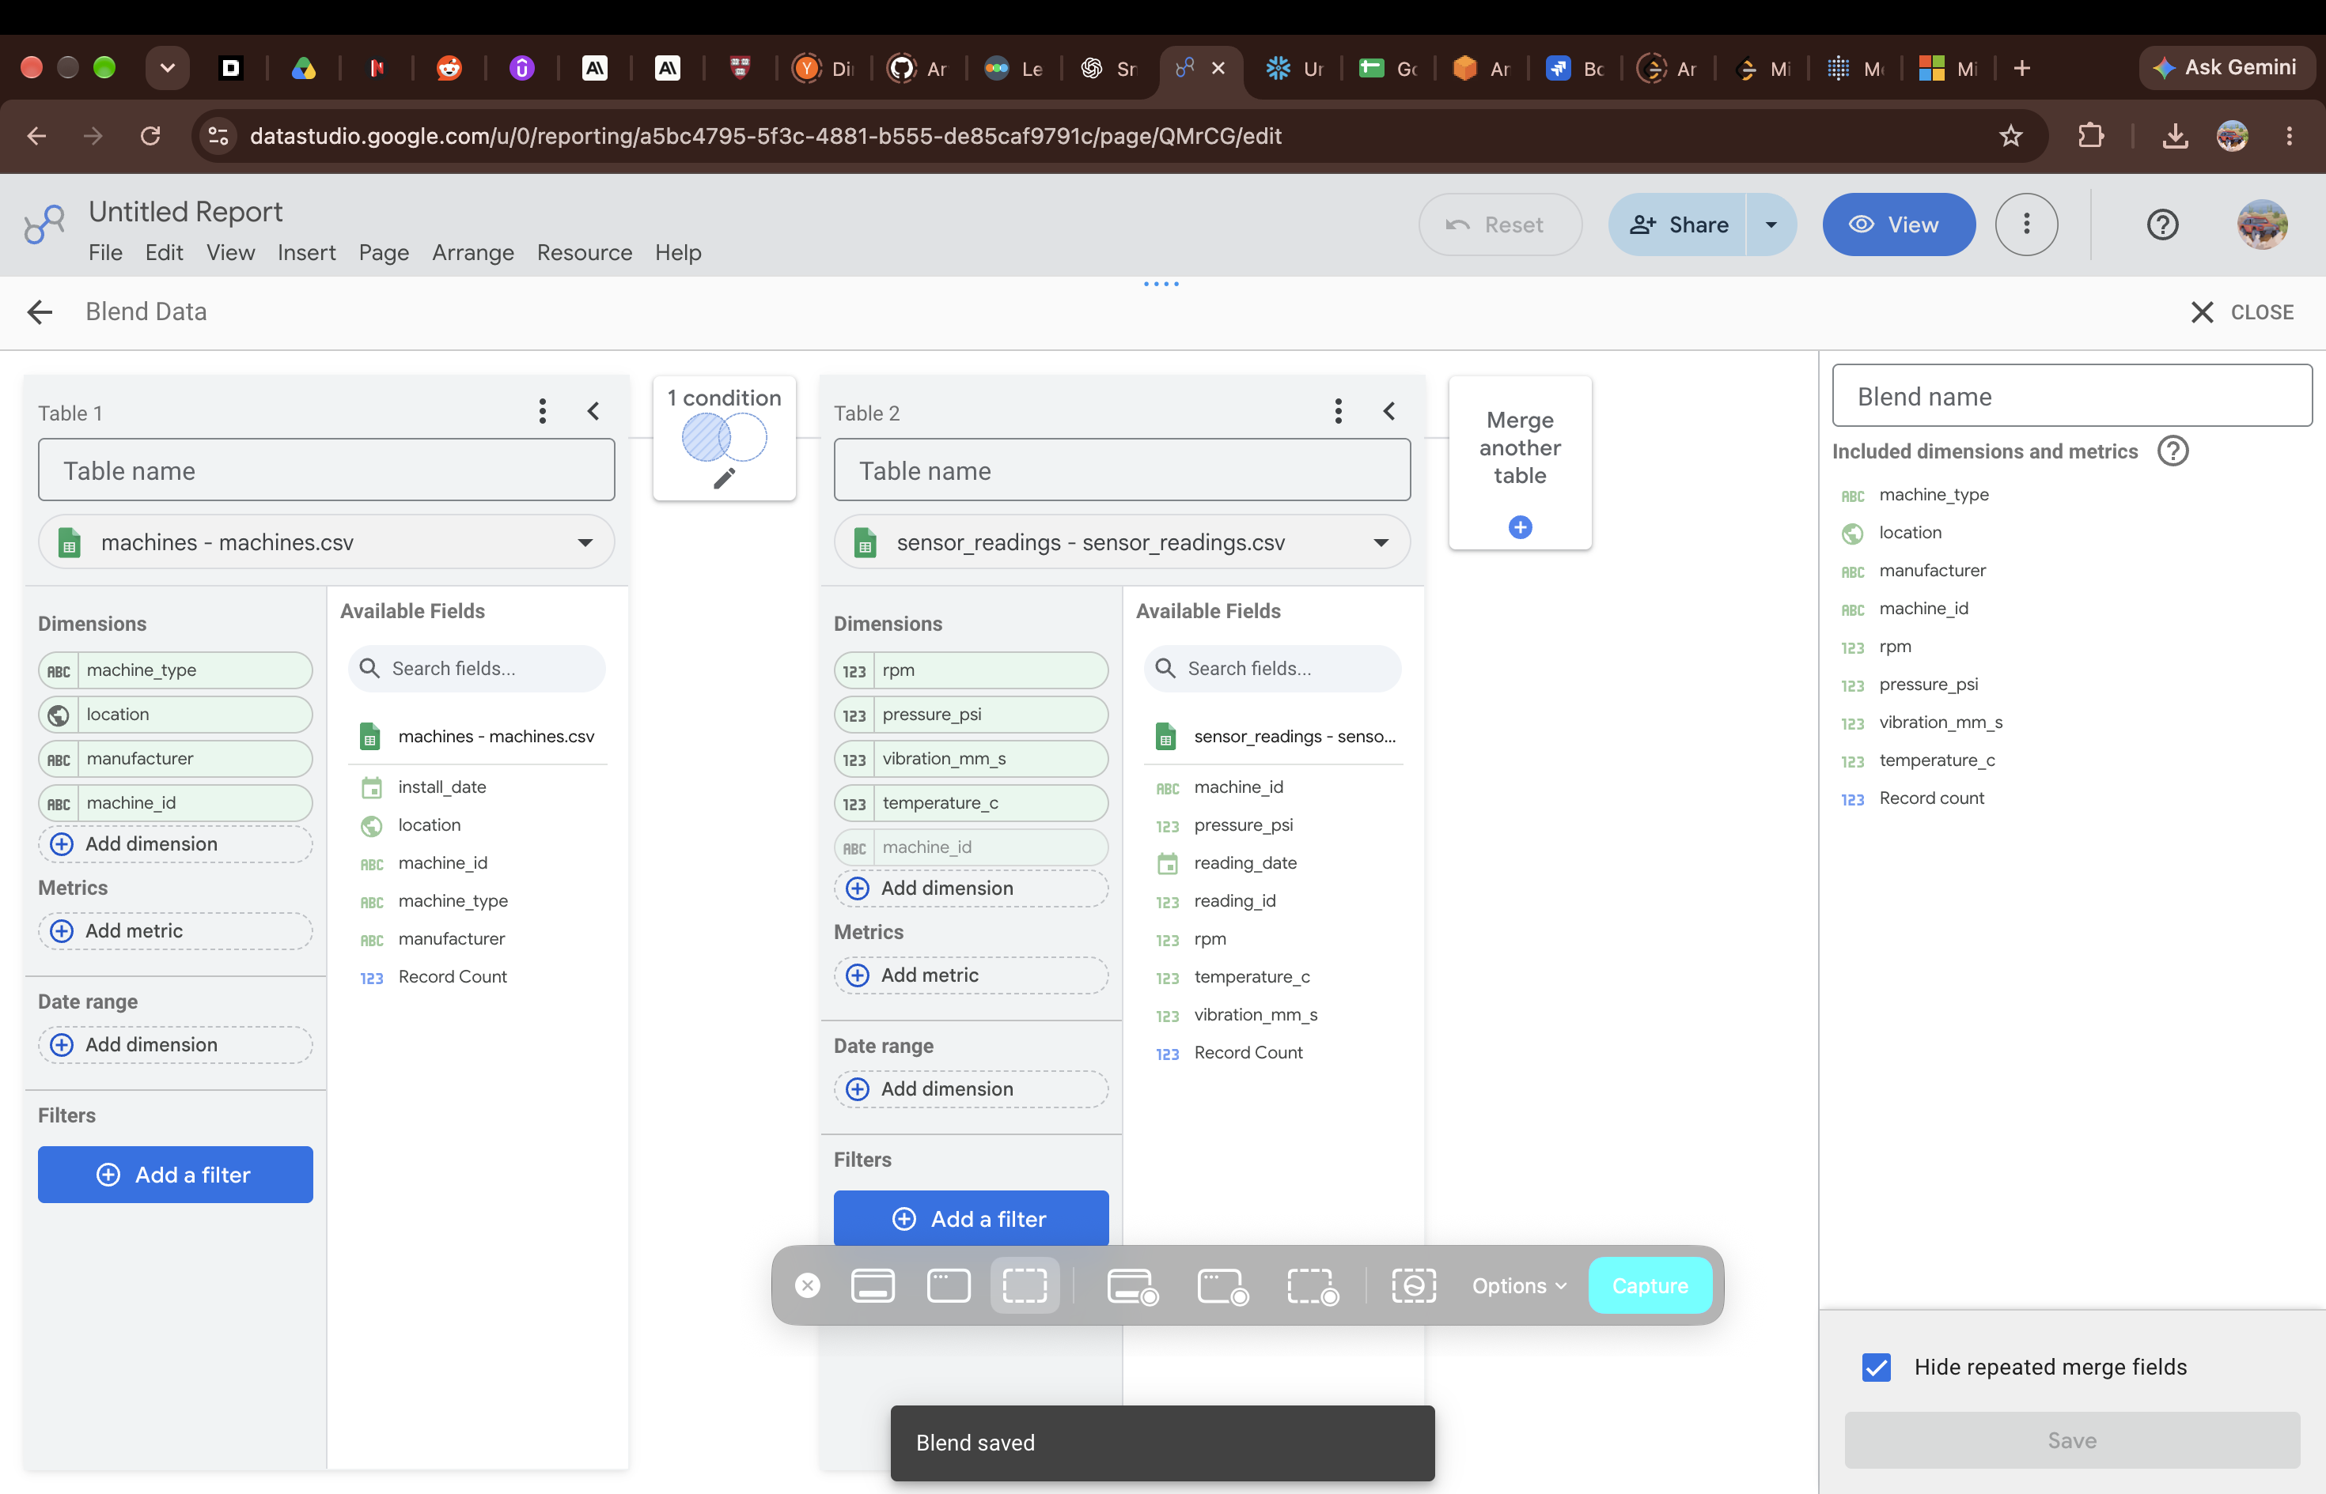
Figure 7 – Machines and sensor_readings blend – sensor measures included, blend saved.
Together, the two blends form a simple model around the machines table:
- machines is the central table, one row per machine.
- maintenance_logs adds cost, downtime and maintenance type per machine.
- sensor_readings adds temperature, vibration, pressure and rpm per machine.

6. Calculated Field
A calculated field was created on the maintenance_logs data source:
- Field name: Total Maintenance Cost
- Formula: SUM(cost_inr)
The field list for maintenance_logs also shows a Total Maintenance field, Record Count, and the source fields cost_inr, downtime_hours, log_id, machine_id, maintenance_date, maintenance_type and technician.
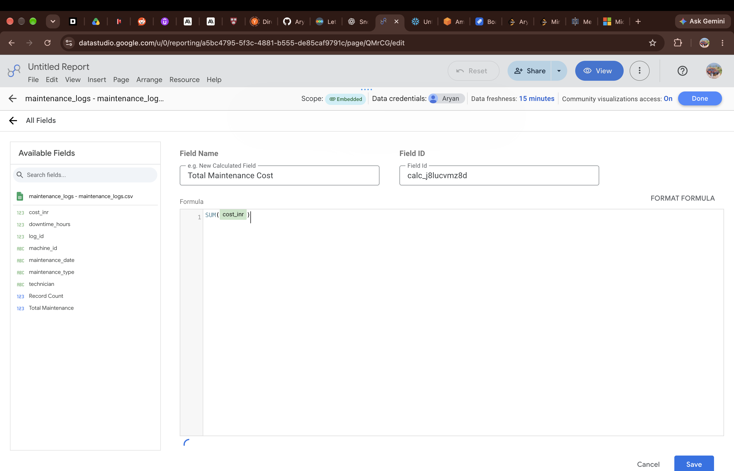
Figure 8 – Calculated field: Total Maintenance Cost = SUM(cost_inr).

7. Dashboard
The report page combines scorecards, bar charts, a pie chart and a table.
- Scorecards along the top, including 15 (machines) and 138 (maintenance records).
- Bar chart of machines by manufacturer.
- Bar chart by location, grouped by machine_type.
- Pie chart of maintenance type: Preventive 29.7%, Corrective 25.4%, Inspection 23.9%, Emergency 21.0%.
- Table of machines with manufacturer, machine_id, location and machine_type, showing 1–15 of 15.
Preventive work is the largest share of maintenance, but at 29.7% it is less than a third of all records. Corrective and emergency work together make up 46.4%, so almost half of the maintenance recorded was unplanned.
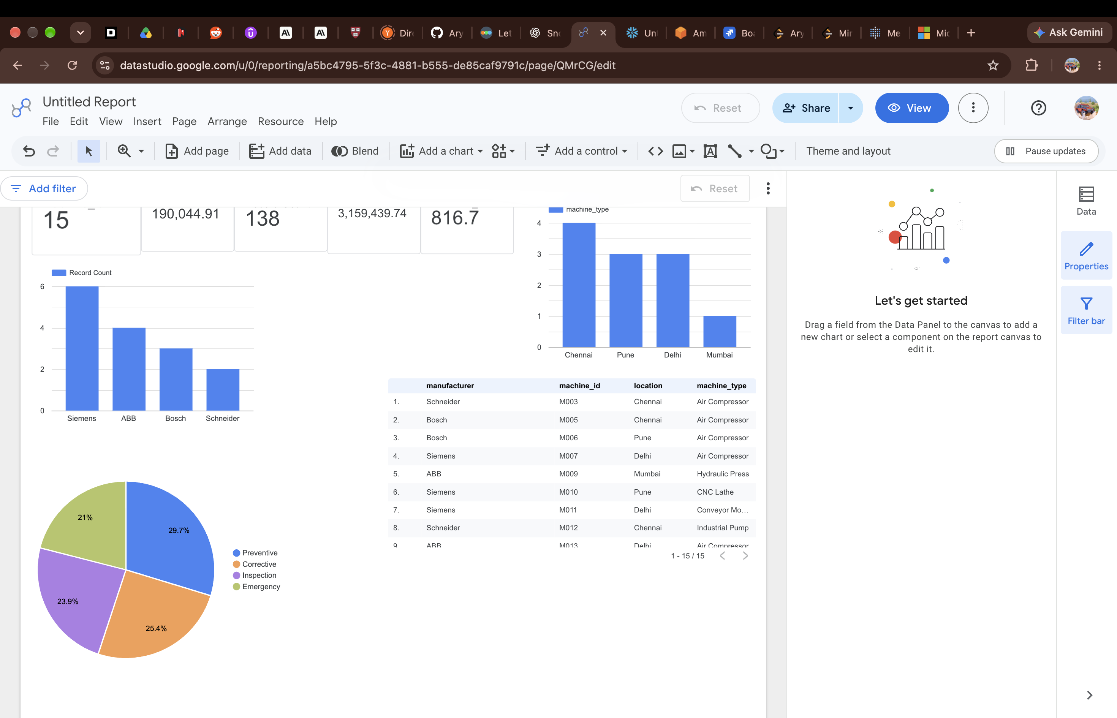
Figure 9 – Dashboard – scorecards, manufacturer and location charts, maintenance type pie chart, and machine table.

